**Mechanical part**

To ensure the control of power flux like charging batteries or charging bicycles directly we have to use an anemometer (CV7-OEM type V) to collect the wind speed Data.

In order to full fill this objective This sensor must be planted on the roof of Maison de la mécatronique, but the problem is this latter is available in our Labs without support, so we have to create a design and after that manufacture it.

**Making a design for the anemometer support**

After discussing with the supervisor of our collective project willy about entire purpose of this support, I fixed with him some important points like

-We have to measure the wind speed with the same altitude as our wind turbine

-Strong system in order to resist against all conditions

-

You can find in the right-side picture the design that I have done for the support.

Characteristics of anemometer support

Length of vertical rod: 2000 mm

Length of horizontal: 180 mm

Connection used: 90° connections with glided system

**Manufacturing of the anemometer support Picture 1 : anemometer support**

You can find bellow pictures of the support that I have manufactured with the help of Mr. Blaise.

**Implementation of the anemometer support on the roof of Maison de la mécatronique**

**Choosing of the place take picture**.

Implementation place of anemometer

**Choosing the type of rod fixing.**

After discussing with Mr blaise and willy I chose the wall attachment shown below in the picture

**Electronic part**

The electronic part was carried out by Nidhal Maghrebi and Anirban Battacharya

**Introduction**

The main objective of our collective research project is to charge 4 batteries or to charge bicycles directly. In order to full fill this objective we have to use some sensors that can help us to collect data and consequently control the charging system.

Among the sensor that we are going to use in this project we can find the anemometer

(CV7-OEM TYPE V) so in this part you will find a detailed description about the anemometer sensor.

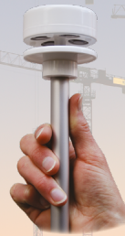**I) Anemometer sensor (CV7-OEM TYPE V)**

Wind speed is one of the most important external parameters of our wind turbine that is why we chose to work with an accurate sensor to measure the speed and direction of the wind as well as the temperature.

As you can see in the picture on the right side, we are going to use an anemometer which is a very accurate ultrasonic wind sensor powered with 8-30 v DC.

**Figure1 :**CV7-OEM TYPE V sensor [1]

**I).1 Data sheet of anemometer sensor**

You can find bellow a table that contains the technical Data about the chosen anemometer.

Figure 2 : Technical Data of CV7-OEM TYPE V sensor [1]

**I).2 Operating mode**

As you can see in the right-side picture this sensor contains 4 transducers (1)

Those devices communicate two by two through ultrasound signal (2) in order to determine according to two orthogonal axes, the difference in the transit time of the waves, induced by the flow of air 3.

The measurements are composed in an integrated calculator that will give the necessary information.

**Figure3:** CV7-OEM Operation mode [1]

**II) Description of the entire system**

As we mentioned before in order to control the flux power of charging system, we need Data from the anemometer sensor to take the necessary information. So, to full fill this object we have to send this Data From the sensor and display it through our computers or to our phones.

In our case We need a system that can send DATA with long distance without consuming huge power.

Here in after you will find a detailed description about the calibration of the anemometer sensor as well as the method that we have chose to send data even there is a long distance between transmitter and the receiver.

**Figure 4:** LORA protocol [**https://wiki.dragino.com/index.php?title=Lora_Shield**](https://wiki.dragino.com/index.php?title=Lora_Shield)

As you can see in the picture above, the system contains.

Lora node or LORA WAY

lora Gateway

Internet of things

**II).1 Definition of LORA PROTOCOL**

Lora (long range) is a system that consist to send a little package of data from sender to a receiver over a long distance. (In our case we do not need to send a huge amount of data and we need to use low transmission power that is why we have chosen LORA)

In this system we can find LORA WAN (wide area network) which is consist of two parts.

-Radio module

-Microprocessor to process the sensor data

**Figure 5:** Description of Lora Wan

We can find also LORA GET WAY which is represent the intermediary that allow sensing devices to transmit data to the cloud (Internet of Things)

**Figure 6:** LORA GET WAY

**II).3 Internet of Things technologies (IOT)**

The Internet of Things refers to the rapidly growing network of connected objects that are able to collect and exchange data in real time using embedded sensors. **Figure 7**: IOT

**In order to full fill our objective we have to follow some steps before such as:**

1-Make the connection between the anemometer and Arduino

2-Collecting Data

3- Sending random Data from the lora module to the lora server through lora gateway

4-Sending the anemometer from the lora module to the lora server through lora gateway

5 sending data from lora server to jeedom.

**1) Connection between the anemometer and Arduino**

At first, we tried to collect Data from our wind speed instrument used the Arduino software so you can so you can find bellows pictures of the necessary connection between the anemometer and the Arduino board after following some instructions that was taken from the data sheet.

**Figure8:** Connection of anemometer sensor

**1.a. Used instruments:**

-DC generator with 12V

-Anemometer sensor

-Arduino board

-Wires for connections

**1.b. Followed instructions.**

As shown in the picture above to make the connection between OEM CV-7 and the Arduino we had to follow the instructions bellow:

Red wire: +12v

Power supply for anemometer

Blue wire: 0V

Yellow wire: Tx (Ensure the transmission of data from the sensor to Arduino)

-We used the 13 and 14 pins to connect the anemometer with Arduino bord

**2. Collecting data**

we tried to make a scripting for the Arduino code but during this task we faced a lot of problems, when we tried to use the Arduino code for last year a lot of errors in the code are appeared and after managing the library, we successfully collect the data from the wind sensor.

You can find bellow the link of nemea.h library that we have used in calibration of our sensor.

<https://github.com/ericbarch/arduino-libraries/blob/master/NMEA/nmea.h>

After scripting the Arduino code, you can see in the picture above the nemea-0183 data which is started with $ and bellow the data are converted with m/s.

**Figure 9 :** nemea-0183 DATA

**3) Sending random Data from the lora module to the lora server through lora gateway**

At first, we made some research about sending data from lora nod (module) to lora server.

After that we created a new application in the THINGS NETWORK account (we used willy account) .

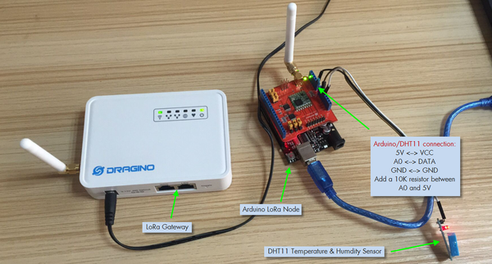

**Figure 10: picture of gateway and lora module**

[**https://wiki.dragino.com/index.php?title=Lora_Shield**](https://wiki.dragino.com/index.php?title=Lora_Shield)

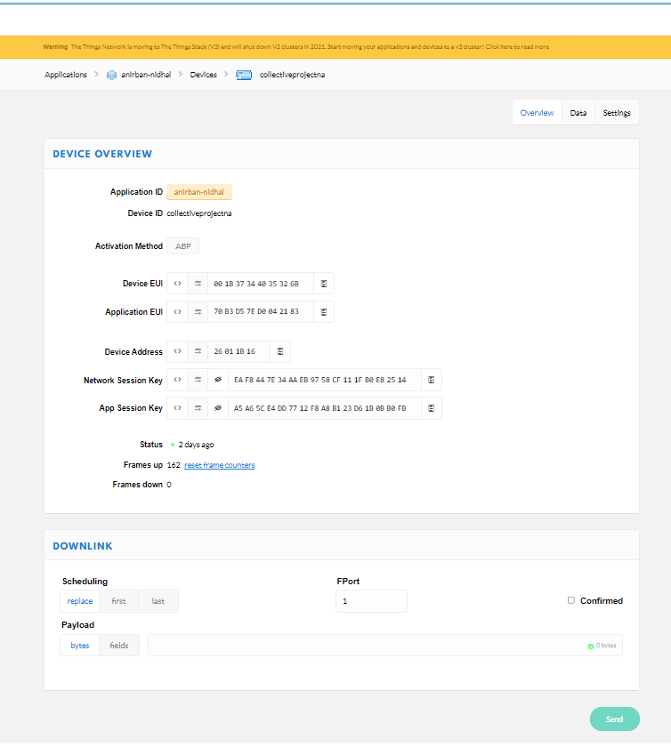

Fig 11 details of the device

Figure 12: Creating new application

For the connection we had registered our device in the application layer of the “THE THINGS NETWORK” and us you can see in the above picture we use ABP activation method , because when we use the lora module to communicate we have to use the Device address, Application session key and Network session Key for each time to communicate (fig 10). in the below picture we make connection with gateway and successfully send the random data from our lora module or lora end ,the out put of the scope id given below .the link of GitHub repository had used for the lora module (<https://github.com/akarsh98/Dragino-Gateway-Demo-1/blob/main/Arduino_Hello_world.ino>)

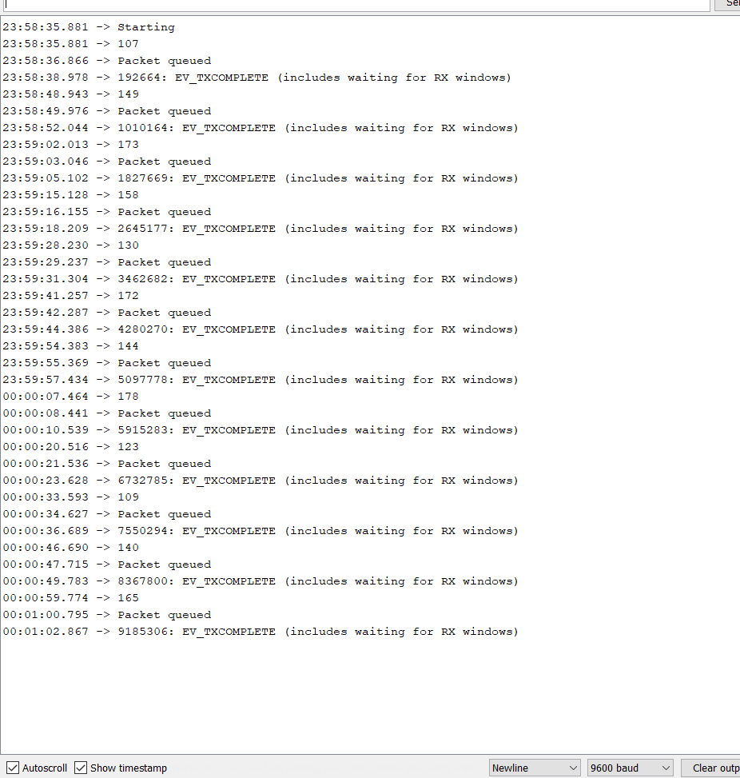

Fig-13 out put of Arduino scope

In order to interpret the data that we will send from the Arduino to the things network (Dragino) we have to use the code in the picture bellow in the payload formats zone of our new application as shown in the second picture.

**Figur13:** Using code

**Figure 14:** The page of the application created.

**SENDING THE WIND SPEED THROUGH THE LORA MOUDLE**

After successfully establishing the connection between the lora module and lora server our next step is to sending the wind velocity to the lora server, for that we have make connection with sensor with lora module ,for data communication we have used pin number 4,5 with the sensor .the details descriptions of the pins of the lora module are given in the picture .

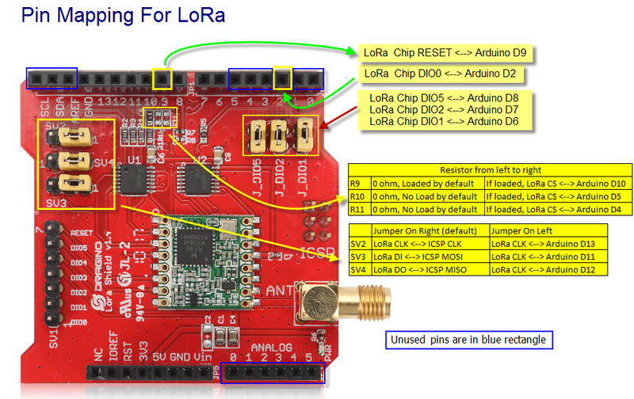

**Figure 14: Pin mapping for Lora (**[**https://wiki.dragino.com/index.php?title=Lora_Shield**](https://wiki.dragino.com/index.php?title=Lora_Shield)**)**

After the connection we have combine and modify the code for the sensor and the code for the data for the sending data for the lorawan and run in Arduino IDE as out put we got the data for the wind velocity .

